DESINING PROFFESIONAL CARDS

INTRODUCTION:

1.1OVERVIEW:

Every card needs a name. Company name-Another given, except for personal brands, in which case your personal name is your company name. Job title- for traditional cards, include your job title. This also helps remind the holder of who you are, what you do, and even how you met.

* 1. PURPOSE:

Well-designed business cards can **help a company differentiate itself and make a positive first impression**. As the first method of communication between you and prospective clients, a business card can be a marketing technique. Their portability can also help promote brand awareness since they're easy to share.

2. PROBLEM DEFINITION& DESIGN THINKING

2.1 EMPATHY MAP

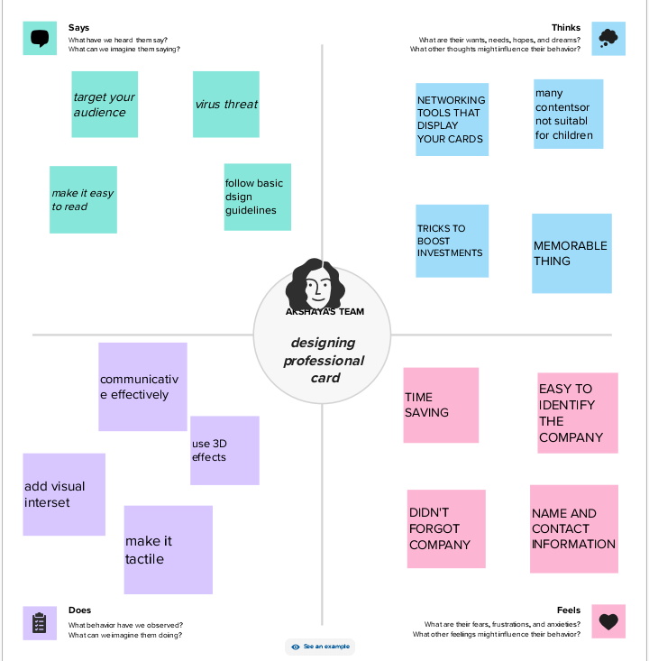

2.2 IDEATION& BRAINSTORMING MAP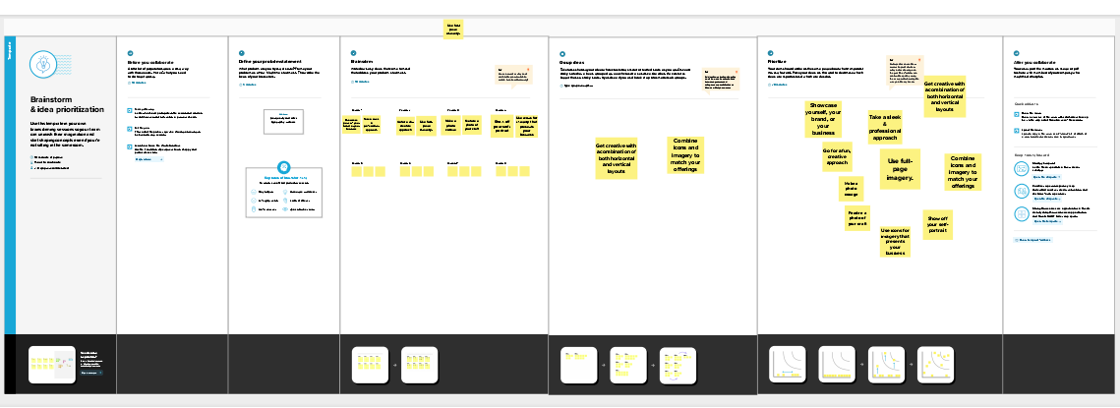

3. RESULT









4. ADVANTAGES OF PROFESSIONAL CARDS

* Easy to Display. Because business cards are so small, there are countless options for how and where you can display them. ...
* Physical Reminder. ...
* Affordable. ...
* Versatile. ...
* Portable. ...
* Great for First Impressions. ...
* Makes Your Brand Bold.

4.1DISADVANTAGES OF PROFESSIONAL CARDS:

* **Fraudulent use of professional cards**
* Company bank cards are sometimes used fraudulently by employees, especially for personal expenses
* . The company therefore risks booking more expenses than necessary for their professional activity.
* Losing money.
* Running into problems if there is a tax control.

5. APPLICATIONS

Creating a professional business card involves design and printing. You can use design software like adobe in design or online tools like canva. Include your name, contact info, logo, and a clean design. Once designed, you can print them at a local print shop or using an online printing service.

6. CONCLUSION

A business card design should target the client's customers and market. Each element used should convey the message. Use of colors and typeface is crucial to give the card a new look and feel.

7. FUTURE SCOPE:

Hosting key business information, such as your website, email and phone number, a business card encourages people to contact you, visit your business (online or in real life) and learn more about you. Another way to encourage customers to engage — and hold on to your business card — is by adding an incentive.